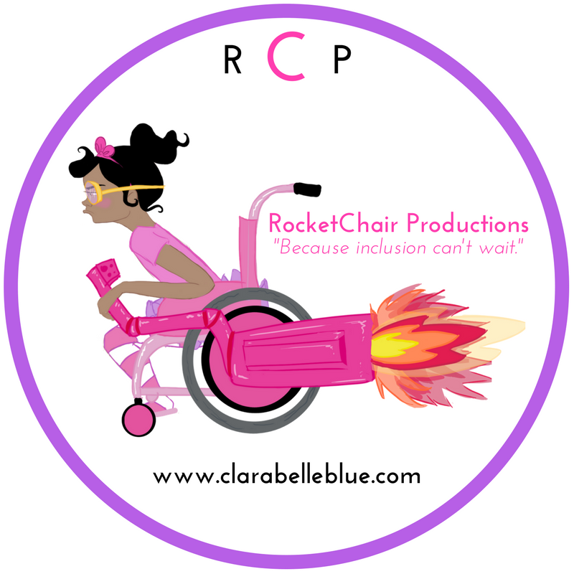
Unpacking Uniqueness: Diversity in our Community
Goals:
Students will employ reflective and analytical thinking to differentiate physical attributes and defining characteristics in order to complete a character analysis of a fictional character and apply their understanding to identify and explain their own unique character.

Learning Objective:
Students will employ descriptive language to analyze a character and their own defining qualities. Students will use analytical thinking to categorize individual qualities and apply their understanding of uniqueness and characteristics to evaluate themselves. Students will identify aspects of others’ characteristics to foster a greater sense of community and appreciation for diversity.

Length:
55 minutes

Materials Needed:
Meet Clarabelle Blue book
8-10 poster papers
2 different color highlighters

Anticipatory Set:
Pose the question to the class, “How would you describe yourself. Who are you?” Instruct the students to complete a 3-5 minute quick write to answer the above question. Encourage your students to include as many describing details as possible. Ask the students to take out two different color highlighters and highlight all the descriptive terms that describe the way they look in one color and the way they think and or behave in another color. Provide students an example of physical attributes versus characteristics. Inform the class that for the purpose of this lesson we are going to examine characteristics more so than physical attributes.

Lesson Procedures:
- Instruct students to practice as a class distinguishing between physical attributes and characteristics by reading the book Meet Clarabelle Blue. Inform the class that you are going to read aloud and the students will complete the Physical Attribute versus Characteristics Chart (see attached) based on their understanding of the book. Ask students to use the text and illustrations to aid them. Inform students to list examples clearly evidenced and possible inferences hinted at in the book complete the Physical Attribute versus Characteristics Chart.
- Ask students to share their finding and create a master class chart. Discuss with students the difference between physical attributes and characteristics to check for understanding. Stress that a personal characteristic describes ones mental and moral qualities. Mental qualities are your thoughts, interests, opinions and dreams. And Moral qualities describe the way that you behave and the way you treat others and yourself. As students share their findings, categorize qualities as being physical attributes or characteristics. Ask students to explain their reasons for their categorization.
- Ask students to revisit their earlier “How would you describe yourself. Who are you?” quick write and determine if they need to make any revisions to their initial categorization of physical attributes and characteristics.
- Write the word Unique on the board. Ask students to turn to a partner and write a definition to the word Unique.
- Ask students to share their definitions. Possibly create a list of synonyms to the term Unique.
- Compare the students’ definition of “Unique” with the dictionary definition “Being the only one of its kind, unlike anything else.” Facilitate a class discussion to develop a class definition of the term pulling from the students’ definition and the dictionary definition.
- Place the students in small groups of 3 or 4 and ask them to determine what characteristics (mental or moral qualities) make Clara Belle Blue unique according to the class definition. Inform students to avoid any physical attributes in their responses.
- Pass out one poster paper to each group. Ask students to draw a picture the unique characteristic their grouped identified for Clara Belle Blue.
- Ask students to report out to the class by sharing their groups picture and explain why this depicts Clara Belle Blue’s unique characteristic.
- Instruct students to use their understanding of the class activity examining uniqueness in Clarabelle Blue’s character to examine their own unique characteristics. Stress that they need to focus only on characteristics (mental and moral qualities distinctive to their individual) not physical attributes. Instruct students to develop a drawing that captures the uniqueness of their character.

- Instruct students to write a one paragraph defense of their image. Why does this image describe characteristics that make them unique? Have students restrict their image to small size. Possibly a 4X6” paper.
- Ask students to share their image and paragraph in a small presentation 2-3 sentence presentation to the class.
- Upon completing their presentation, instruct students to hang their picture in a manner that would create a sort of patchwork quilt mural entitled “The Unique Characteristics of Us”
Assessment:
Students will demonstrate their understanding of the lesson by completing the Debrief Worksheet that asks students to identify 3 things they learned about their classmates’ unique character and to accurately distinguish between characteristics and physical attributes.

Quick Write
Directions: How would you describe yourself. Who are you?
_______________________________________________________________
_______________________________________________________________
_______________________________________________________________
_______________________________________________________________
_______________________________________________________________
_______________________________________________________________
_______________________________________________________________
_______________________________________________________________
_______________________________________________________________
_______________________________________________________________
_______________________________________________________________
_______________________________________________________________
_______________________________________________________________
_______________________________________________________________
_______________________________________________________________
_______________________________________________________________
_______________________________________________________________
_______________________________________________________________
_______________________________________________________________
_______________________________________________________________
_______________________________________________________________
_______________________________________________________________
_______________________________________________________________
_______________________________________________________________
_______________________________________________________________
_______________________________________________________________
_______________________________________________________________
_______________________________________________________________
_______________________________________________________________
_______________________________________________________________
_______________________________________________________________
_______________________________________________________________
_______________________________________________________________
_______________________________________________________________
______________________________________________________________
Physical Attribute versus Characteristics
Directions: Complete the chart with words and phrases that describe Clara Belle Blue’s Physical Attributes and Characteristics. Use the text and illustrations to draw evidence and make inferences (educated guesses rooted in evidence) to complete the chart.
Physical Attribute  Describe her appearance. What does she look like? | Characteristics  Describe her mental qualities such as her thoughts, interests, opinions and dreams and moral qualities like the way that you behave and the way you treat others and yourself.

Debrief Worksheet
Directions: Identify 3 things you learned about 3 different classmates throughout the class presentations.
- Name of Classmate _____________________________________________
I learned that he/she ___________________________________________
_____________________________________________________________
- Name of Classmate _____________________________________________
I learned that he/she ___________________________________________
_____________________________________________________________
- Name of Classmate _____________________________________________
I learned that he/she ___________________________________________
_____________________________________________________________

Explain in 1-2 sentences how characteristics differ from their physical attributes.

______________________________________________________________________________
______________________________________________________________________________
______________________________________________________________________________
______________________________________________________________________________

