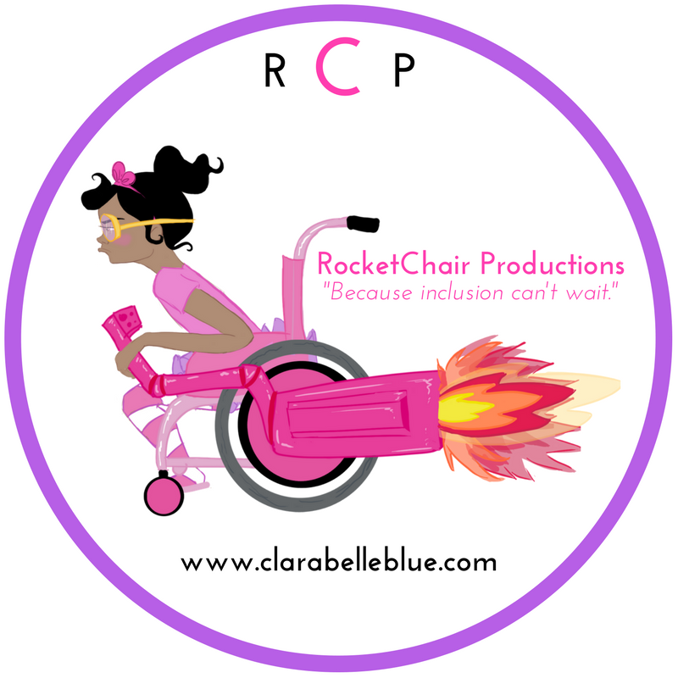

Problem Solving to Achieve Playground Inclusion:
What Does Clara Belle Blue Teach Us About How to Achieve Inclusion

Goal: Students will explore the mechanics of inclusive play.

Learning Objective: Students will examine an illustration and apply their comprehension of a text to apply their skills in problem-solving skills for the purpose of achieving inclusion in real life scenarios.

Length: 55 minutes

Materials Needed:
Visual cue cards
Play Scenario Cards
Poster Paper
Crayons

Anticipatory Set:
Facilitate a whole class discussion by asking students to share their favorite play activity on the playground. Inform students that sometimes we need to use our problem-solving skills to find ways to play with all our friends and that today we are going to listen to a story and participate in an activity that will challenge us to find ways to play with everyone.

Lesson Procedures:
- Inform students that you will read the story “Meet Clara Belle Blue” and ask them to listen for the various play activities Clara Belle Blue engages in the story.
- Check for student comprehension of the story by facilitating a whole class discussion in which students identify the various play activities.
- Point students to examine the illustration of Clara Belle Blue jump roping. Ask students to identify the challenge that jump roping posed Clara Belle Blue and how did Clara Belle Blue solve this problem.
- Inform students that we are going to use the same problem-solving skills Clara Belle Blue used in the story to find ways to play with our friends that have special needs. If necessary, review the term special needs by referring back to the book’s definition. This will allow more opportunity to reinforce comprehension of the story.
- Place students in groups of 2-3. Distribute one Visual Cue Card and Play Scenario to each group. Ask the students to use their problem-solving skills to achieve inclusive play addressing their given scenario.
  - You may need to model problem-solving strategies. Use Clara Belle Blue jumping rope as an example; First Identify the Challenge, Second Brainstorm Solutions, Last Select the Best Possible Solution.
- Ask students to draw a picture of their solution to the assigned play scenario and use this picture to report out to the class.
- Invite students to share their outcomes and use their picture to aid in their explanation.
- Facilitate a whole group or partner discussion that asks students to reflect on all the presentations to determine which inclusive play that would enjoy the most and why.

Assessment:
Students will present their solutions to the assigned scenarios. Check that students addressed the given scenario in manner that achieves inclusion.

Enrichment: Ask students to select a piece of playground equipment that they could redesign to make more inclusive. Make a model of their redesigned equipment to share with the class.

Scenarios:
1: Jump Rope - You and 5 friends are on the school playground, and you want to play jump rope. One of your friends uses a wheelchair. What can be done so that all of you can play jump rope together?

2: See Saw (Teeter Totter) - Jenny came over for a playdate and you decide to go to the park. Jenny has a hard time keeping her balance, and often needs help sitting up straight, but she wants to play on the see saw. How can you fix the see saw so you can BOTH play on the see saw together?

3: Hop Scotch - Charles uses crutches to get around but his favorite thing to do is play Hop Scotch. He sometimes struggles when he gets to the 2&3, and the 5&6. Can you think of things he can do to still get credit for those numbers WITHOUT putting a foot on each of them?

4: Soccer - You’ve just gotten to the park with 10 of your friends and you all want to play soccer. 3 of your friends are cannot see (blind). Look at the items in this box and figure out how you can ALL play soccer together - even your friends who cannot see. Here’s a hint: Think about your OTHER senses.

