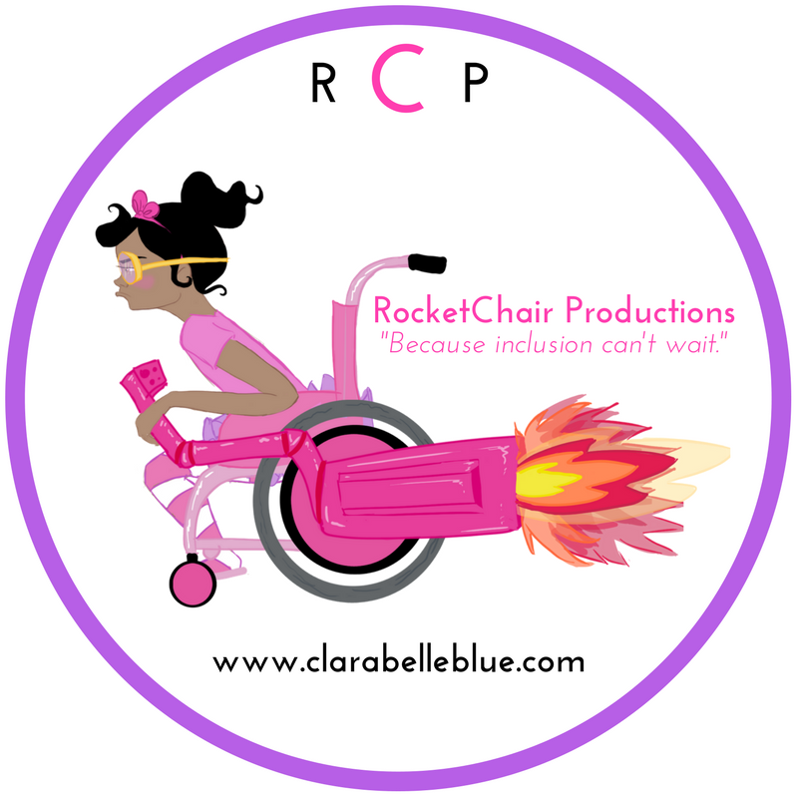

Clarabelle Blue is Just Like You:
Creating Connections and Community through Reflective and Critical Thought

Grade Level: K-3

Goals: Students will gain an appreciation for the connections they share with their peer group including students with special needs and foster acceptance of inclusion and a greater sense of community in the classroom.

Learning Objective: Students will engage in reflective and critical thinking to identify and examine commonalities shared with their peers. Students will demonstrate comprehension of the book Meet Clarabelle Blue by deconstructing the main character’s defining characteristics and drawing inferences regarding Clarabelle Blue’s attributes and interests in order to identify commonalities shared with themselves and their peers. Students will apply their understanding of shared commonalities to create an inclusive recess activity that is rooted in shared interests.

Length: 55 minutes

Materials Needed:
The book Meet Clarabelle Blue
Description Worksheet (See Attached)
Highlighters
Pencils
Large Blank Drawing Paper

Anticipatory Set:
Prompt students to reflect on themselves by asking them “Think of 5-10 ways you can describe yourself.” Encourage them to avoid physical attributes. Ask students to “Think about 5-10
things they really enjoy doing.” Encourage them to think about school related and playground activities that they find really fun. Instruct students to list their attributes and activities on a the “About Me” section of the Description Worksheet. Teacher may want to model reflective thinking this activity requires by completing the “About Me” section of the Description Worksheet about him or herself under a document camera or on the board.

Lesson Procedures:
- Pair students in groups of two. Ask students to share their “About Me” section of the Description Worksheet with a partner. Instruct students to practice their active listening skills and check their understanding of their partner’s information by recording their partner’s information on the “About Your Partner” section of the Description Worksheet.
- Instruct students to find as many commonalities or similarities they share with their partner. These shared attributes and activities do not need to be restricted to items previously recorded on the Description Worksheet. Students can add to their lists if they think of additional items during this portion of the activity. Use the worksheet as a springboard to facilitate discussion between partners and possibly expand their original thoughts.
- Ask students to highlight all the attributes and activities they share with their partner.
- Inform students that you are going to read aloud the book Meet Clarabelle Blue. Ask students to listen carefully to the characteristics describing Clarabelle Blue.
- Read the book Meet Clarabelle Blue aloud to the class.
- Facilitate a whole class discussion. Ask the class how would Clarabelle Blue complete the Description Worksheet. Encourage them to make inferences beyond the text in assessing her character. Instruct them to think about the following questions: “How would she describe herself? What activities would she enjoy doing?” If students are inferring an attribute or activity, ask them to explain what in the book makes them think this. Ask students to use facts in the book as the basis for their inferences to assure activity remains rooted in the text.
- Instruct students to record their findings from the book and discussion on the Description Worksheet under the “About Clarabelle Blue” section.
- Ask students to go back to their partners and use the Description Worksheet to identify similarities between themselves and Clarabelle Blue. Ask students to highlight any attributes or activities they listed in the “About Clarabelle Blue” section of the Description Worksheet that they share in common with Clarabelle Blue.
- Ask students to select 3 to 5 commonalities they both share with Clarabelle Blue and record their findings in the “We All Share in Common” section of the Description Worksheet.

Assessment:
Students will employ their understanding of the similarities they share with their peers and Clarabelle Blue to design a perfect recess playing together in a way that incorporates their shared commonalities. Prompt students to work with their partner to answer the following question.
“Imagine Clarabelle Blue was coming to visit our class for the day. You and your partner will play with her at recess. What will you play that you will all enjoy.”
Instruct students to draw a picture of them playing a recess. Ask students to share their pictures with the class and explain what they will all play together and why it will be fun for all involved.

Enrichment: Instruct students to organize the information gathered from their reflection, small and large group discussions and recorded on the Description Worksheet into a Venn Diagram that includes 3 circles to compare and contrast 3 individuals. The Venn Diagram will identify commonalities and differences shared between the student, student’s partner and Clara Belle Blue.

Name____________________
Description Worksheet

About Me
Ways I describe myself: | Things I like to do:

About Your Partner
Ways You describe yourself: | Things you like to do:

About Clarabelle Blue
Ways Clarabelle Blue describe herself: | Things Clarabelle Blue likes to do:

We all share the following in common:

