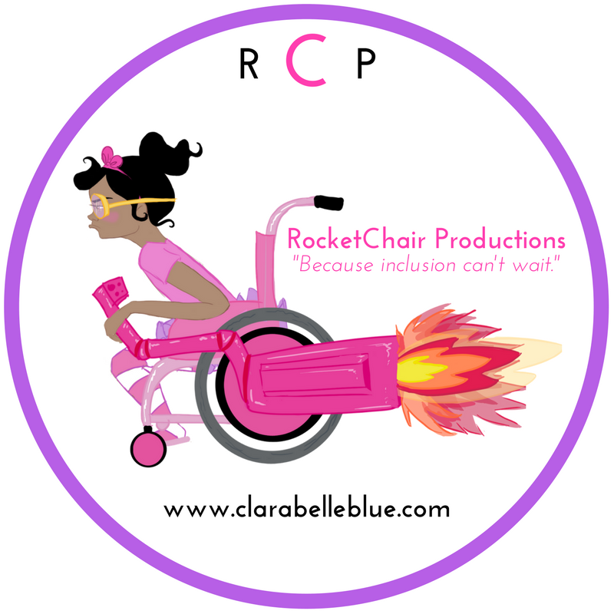

Connecting with Clarabelle Blue
Goals:
Building self and text connections through visual interpretations and class discussion.

Learning Objective:
Students will make predictions using visual cues, recall favorite passages from a story and use descriptive language to share connections they have made with the text.

Suggested Grade:
K-1

Length: 20-30 minutes

Materials Needed:
The Book Meet Clara Belle Blue
Paper
Crayons
Chart Paper

Anticipatory Set:
Facilitate a class discussion that asks students to make observations about the book cover. Ask students what they see. Ask students how Clara Belle Blue looks and what she might be feeling. Ask them what do you think will happen in the book.

Lesson Procedures:
- Read Clara Belle Blue to the class aloud.
- Ask students to think of their favorite part of the book and draw a picture of this scene.
- Invite the students to share their pictures and write down thoughts, ideas and description about their picture.
- Support student connections with the text by asking “How and Why” questions that support their elaboration skills.
Assessment:
Check for understanding throughout lesson in an informal discussion manner.

